Costed Plan for Electric Petrol WAN

Introduction
This costed plan shows the proposed wide area network or WAN connectivity between the head office in Skerries and its other sites. These sites are Balbriggan, Knock (DataCentre1) and Buncrana (Datacentre2). The network design consists of a robust architecture and has redundancy built-in with one primary internet link and two redundant links (one fibre, one wireless with 4G/5G). It prioritises business continuity, high availability and redundancy by implementing a multi-layered approach to connectivity.

Key Design Principles of the Network

Thorough analysis of network infrastructure
- This detailed mapping of ISPs in the relative areas and fibre routes at each site.
- confirmation of physical redundancies in the network.
- Assessment of regional limitations regarding network connectivity.

Robust Connectivity Framework
- Two high-availability fibre optic lines at each site, a primary and a secondary.
- 4G/5G wireless backup options where possible for each location.
- No single point of failure (i.e fibre line goes down, the site is still live).

Safeguarded Network Design
- A Site-To-Site VPN tunnel is used for each site for inter-location communication.
- OSPF Dynamic Routing is used for path optimisation and failover.
- SSL VPN with an optional FortiClient IPsec VPN for secure remote access when not at the sites.

Business Continuity Assurance
- A Minimum of three different ISP connections per site, two fibre and one wireless.
- Multiple paths to primary and secondary data centres.
- Automatic failover set up for uninterrupted operations, no downtime.

Site-Specific Connectivity & Redundancy

Head Office (Skerries)
This site is situated in Skerries, Fingal, Co Dublin. The site is to be constructed in the location found in the image below. The following reasons for this:
- Close to the main road = Easy access for both staff and contractors.
- Close to the local train station = Staff living outside of skerries can get to the site easily.
- Fiber is readily available in this location
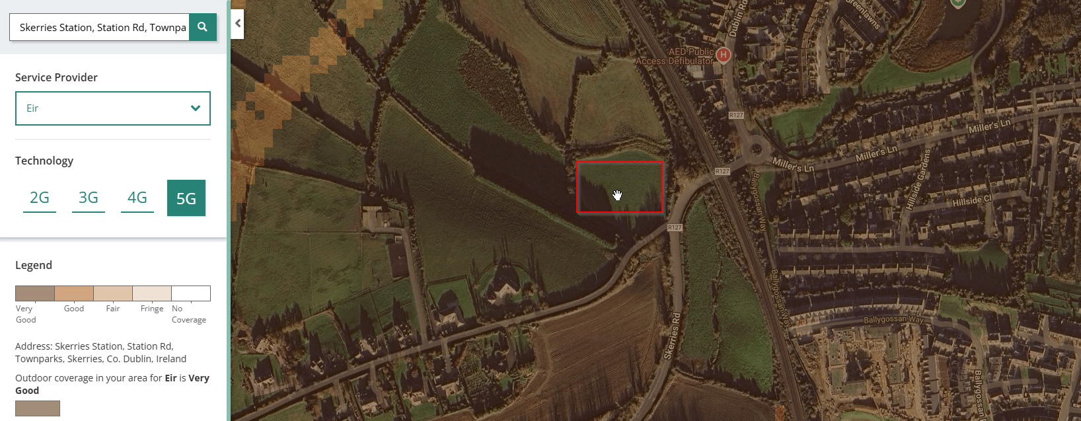

- The fibre solutions for Skerries are:
  - Primary: Eir business 10Gbps (Most accessible and most reliable). €10,000
  - Secondary: Enet MAN (Metropolitan Area Network on behalf of the Irish government) and ESB Backhaul 10Gbps(a National Fibre optic backhaul network for ISPs). - €9,000
  - Backup: Vodafone 5G Business (Static IP and unlimited data solution). - €2,400

- The justification for this is:
  - Eir gives the most reliability over the Island of Ireland but at a cost.
  - Enet MAN + ESB Backhaul provides an independence from Eir.
  - 5G backup provides connectivity should both the primary and secondary lines fail.

DataCentre1 (Knock)
This site is situated near Drumcrest in Knock, Co Mayo. The site is to be constructed in the location found in the image below. The following reasons for this:
- Large scale tourism = Knock sees many visitors both going to the airport and to visit the knock shrine. This means that the Irish government will likely heavily invest in this area in the near future.
- Residential area = Staff members have quick access to the workplace.
- Situated next to National Road = The N17 allows for HGVs and large-scale traffic to visit electric petrol.
- Fibre = Fibre is available in Knock as well as 4G.
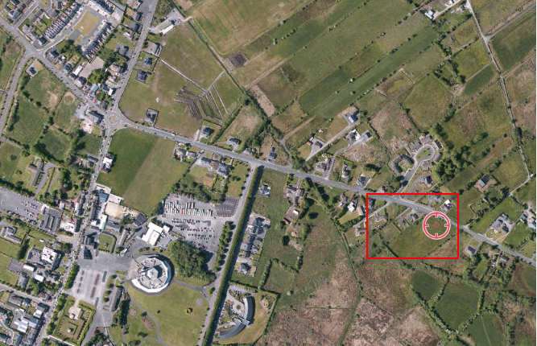

- The fibre solutions for Knock are:
  - Primary: Vodafone 2 Gigabit Full Fibre 2GBps - €8,000)
  - Secondary: Eir 1Gb full Fibre – (1Gb - €4,000)
  - Backup: Three 4G Business Broadband (100Mbps - €3,000)

- The justification for this is:
  - Vodafone - Vodafone is the best provider in the area for cost and the provider is different to the Head office site. This allows for business continuity should one site go down.
  - Eir 1G full Fibre – Knock is an area with very poor speeds. Eirs 1Gbps plan is the fastest speed available to the site (Vodafone is on the same line but is not found on other sites, so it serves as the best option for primary) while also allowing for different providers as the primary.
  - Three 4G Business Broadband – This wireless provider is the only backup option for the region. 5G is not found in the area as per the comreg coverage map.

DataCentre2 (Buncrana)
The Buncrana site is situated near hillhead road in Buncrana in Donegal. The datacentre is to be constructed in the specified site below. The following reasons for this are:
- Main road access = the site is adjacent to the main road coming both in and out of Buncrana. People and goods coming to and from the datacentre should have easy access.
- Residential area = The site is a large open space near a town. Having a datacentre here would create many jobs for residents while still being far enough out of town to not cause an issue.
- Very good internet connection – 5G is readily available in the main town. It also has an expansive fibre network for the datacentre
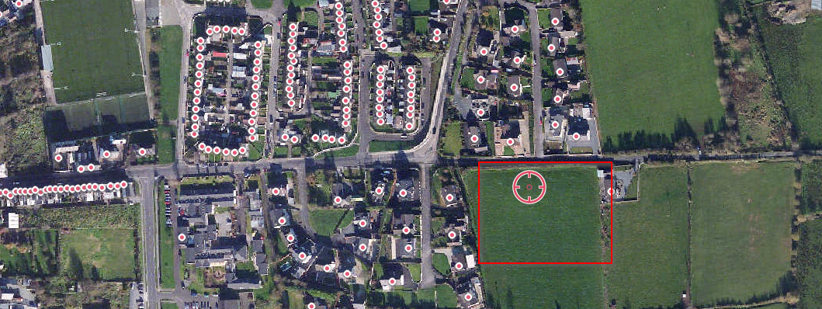
- The fibre solutions for Buncrana are:
  - Primary: Sky Business Broadband (10GBps - €10,000)
  - Secondary: Virgin Media Fibre Broadband for Enterprise business 2GB - (€5,000)
  - Imagine Business broadband (300mbps - €2,000)

- The justification for this is:
  - Sky – Sky Business Broadband is part of SIRO, which has been in Buncrana since 2023. It is different to the other sites and can support 10GBps for large businesses such as a datacentre.
  - Virgin Media - Virgin Media fibre broadband is available in the region (found using an Eircode from Buncrana on Virgins website and virgin specified it themselves) at 2GBps. This is better than 1GB and is different to the other sites.
  - Imagine – Imaging Business broadband is a wireless option should the fibre go offline. It is not in use in any other site and will serve as a good temporary backup.

Electric Petrol Site (Balbriggan)
There is an Electric Petrol site found in Balbriggan near Seapoint road. The service station is to be constructed at this location below for the following reasons:
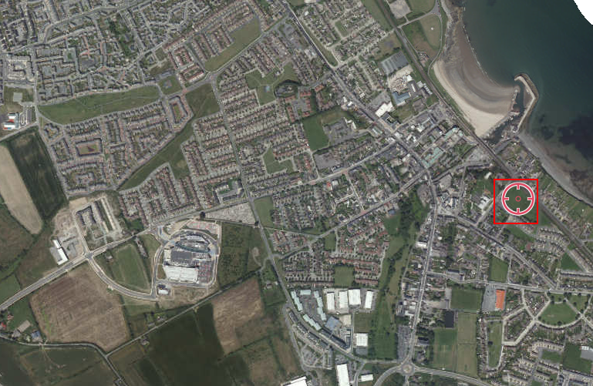
- Situated near the train station = Employees and customers can come off the train to either work or purchase food + services.
- Near multiple residential estates = Potential customers would be very close to the site. This would enable easy access and possibly receive customers who wouldn’t have normally provided their custom.
- SIRO town = Balbriggan is a SIRO town. This means that businesses in the region can get network speeds of up to 10GBps.

- The fibre solutions for Balbriggan are:
  - Primary: Pure Telecom Business (10GBps - €11,000)
  - Secondary: Digiweb Business Broadband (1GBps - €4,000)
  - Backup: Magnet Plus 4G backup (100Mbps – €2,000)

- The justification for this is:
  - Pure Telecom is a reliable option while being a different provider to the other sites. It can provide speeds of up to 10GBps to the site.
  - Digiweb Business Broadband is also different to the other sites but its package of 1GBps is also cost-effective for the region. This also comes with technical support should it go offline.
  - Magnet Plus 4G backup is also unique to the other sites and can provide 4G wireless internet to the site should the fibre go offline. It is also very competitive at €2,000)

Costed Implementation Plan
Below is the costed implementation plan. The figures are obtained from broadband providers in the relative regions and their costs have been calculated. The total cost of the infrastructure has also been calculated.
Site | Primary Link | Secondary Link | Backup Link | Total Annual Cost
Skerries (Head Office) | Eir 10Gbps (€10,000) | ENet MAN + ESB (€9,000) | Vodafone 5G (€2,400) | €21,400
Knock (DataCentre1) | Vodafone 2Gbps (€8,000) | Eir 1Gbps (€4,000) | Three 4G (€3,000) | €15,000
Buncrana (DataCentre2) | Sky 10Gbps (€10,000) | Virgin Media 2Gbps (€5,000) | Imagine Wireless (€2,000) | €17,000
Balbriggan | Pure Telecom 10Gbps (€11,000) | Digiweb 1Gbps (€4,000) | Magnet 4G (€2,000) | €17,000
Total |  |  |  | €70,400

In terms of actual implementation, it can be completed in three phases.
Phase 1: Obtaining the infrastructure.
- Order the fibre links from all the relative providers in Ireland (Pure Telecom, Sky, Eir etc)
- Order the backup solution (Vodafone, Three, Imagine, Magnet Plus)

Phase 2: Configuring the network
- IPSEC VPN Setup: Site-to-site tunnels set up and configured correctly between all locations.
- OSPF Routing: Configuring dynamic routing for automatic failover.
- QoS Policies: Prioritising VoIP, OSPF and backup traffic.
Phase 3: Testing & Cutover
- Failover testing: Simulating any possible fibre downtime to verify that the backup links are operational and function correctly.
- Latency checks: Ensuring that wireless backups meet required service level agreements.
- Finalise documentation: Creating and maintaining network diagrams, persons of contact within ISPs, escalation paths i.e what person reports to who. Overall, this is useful for referring to when diagnosing issues within the network.

Conclusion
The Proposed WAN architecture is designed for Redundancy, High Availability and Business Continuity across all the Electric Petrol sites. Each site is located with the following:
- Primary high-speed fibre for maximum performance in each location
- Secondary diverse fibre routes for maximum redundancy.
- Wireless 4G/5G backup links in case of fibre outages.
- Cross-connected datacentres for disaster recovery and failover.
This type of approach to a WAN architecture allows for up to 99.999% uptime (five-nines) while also minimizing downtime risks and optimizing the reliability of the network. The cost breakdown as shown above and the phased deployment strategy of the costed implementation of the plan also supports an easy transition. This ensures the futureproofing and resilience of the network.

